# **“IMMUNOSHIELD”**

# **Second year Mini Project Report**

# **Submitted in partial fulfillment of the requirements**

# **of the degree**

# **BACHELOR OF ENGINEERING IN COMPUTER**

# **ENGINEERING**

# **By**

**Group No : 24**

# **Aaditya Auml Raikar/54**

# **Varun Avinsah Budhani/10**

# **Yash Pradeep Jha/33**

# **Shantanu Rahul Bhosale/08**

# **Supervisor**

# **Prof. Sujata Khandaskar**



**Department of Computer Engineering**

Vivekanand Education Society’s Institute of Technology

HAMC, Collector’s Colony, Chembur,

Mumbai-400074

# **CERTIFICATE**

This is to certify that the Mini Project entitled **“Immunoshield”** is a bonafide work of Aaditya Raikar(54) , Varun Budhani(10) , Yash Jha(33) , Shantanu Bhosale(8) submitted to the University of Mumbai in partial fulfillment of the requirement for the award of the degree of **“Bachelor of Engineering”** in **“Computer Engineering” .**

### **(Prof. )**

Supervisor

### **(Prof. ) (Prof. )**

Head of Department Principal

# **Mini Project Approval**

This Mini Project entitled “Immunoshield**”** by Aaditya Raikar(54) , Varun Budhani(10) , Yash Jha(33) , Shantanu Bhosale(8) is approved for the degree of **Bachelor of Engineering** in **Computer Engineering.**

## **Examiners**

**1………………………………………**

(Internal Examiner Name & Sign)

### **2…………………………………………**

(External Examiner name & Sign)

Date:

Place

# **Contents**

### **Abstract ii**

### **Acknowledgments iii**

### **List of Abbreviations iv**

### **List of Figures v**

### **List of Tables vi**

### **List of Symbols vii**

### **Introduction 1**

* 1. Introduction
  2. Motivation
  3. Problem Statement & Objectives

### **Literature Survey 11**

* 1. Survey of Existing System
  2. Limitation Existing system or research gap
  3. Mini Project Contribution

### **Proposed System (eg New Approach of Data Summarization ) 18**

* 1. Introduction
  2. Architecture/ Framework
  3. Algorithm and Process Design
  4. Details of Hardware & Software
  5. Experiment and Results
  6. Conclusion and Future work.

**Abstract**

The Indian Child Vaccination Status system is a strategic and technologically advanced platform designed to address the intricate landscape of child vaccination across the country but keeping a record of who is vaccinated and who is not by the local hospitals and private doctors which is still done manually also there are many places which are not easily accessible, and the people there are still scared of vaccines. The main aim of building our project is to efficiently handle data related to children’s vaccination status as well as to track efficiency of the health care workers .It outlines a user-friendly system that manages crucial information, including vaccination schedules, doses administered, and healthcare professional details. By integrating secure databases, this system ensures accurate tracking and seamless communication between parents and healthcare providers. With a focus on accessibility and data integrity, the Child Vaccination Management System aims to enhance the overall efficiency of pediatric healthcare, promoting a proactive approach to child immunization.

### 

### 

### **Acknowledgments**

We would like to express our sincere gratitude to all those who contributed to the development and implementation of the child vaccination management system.

First and foremost, we extend our heartfelt thanks to Mrs.Sujata Khandaskar for their invaluable guidance, support, and mentorship throughout the project. Their expertise, encouragement, and constructive feedback were instrumental in shaping the success of this endeavor.

We are deeply grateful to the healthcare professionals and experts who generously shared their insights, expertise, and feedback during the planning and development phases of the vaccination management system. Their expertise and collaboration were crucial in ensuring the accuracy, reliability, and effectiveness of the platform.

We would also like to extend our appreciation to the parents, caregivers, and children who participated in the pilot testing and provided valuable feedback on the usability and functionality of the vaccination management system. Their input played a pivotal role in refining and improving the platform to better meet the needs of its users.

Additionally, we acknowledge the contributions of our fellow team members, whose dedication, creativity, and collaborative spirit were essential in bringing the vaccination management system to fruition. Their collective efforts and teamwork were fundamental to the project's success.

Furthermore, we express our gratitude to Rashmi Nayar , Balasubramanyam Pattath , Nivedita Mantha , Sisir Debnath , Sarang Deo . Their studies on child vaccination trend was crucial in enabling us to carry out research, development, and implementation activities.

Last but not least, we would like to thank our families, friends, and loved ones for their unwavering encouragement, understanding, and patience throughout the duration of this project. Their support provided us with the motivation and strength to overcome challenges and achieve our goals.

In conclusion, we acknowledge with gratitude all those who contributed to the child vaccination management system project, directly or indirectly. Their collective efforts and support have been instrumental in advancing the cause of child health and vaccination in our community

### 

### 

### **List of Abbreviations**

Here is a list of abbreviations used in the provided project:

1. WHO - World Health Organization

2. NCBI - National Center for Biotechnology Information

3. UNICEF - United Nations International Children's Emergency Fund

4. ER Diagram - Entity-Relationship Diagram

5. EHR - Electronic Health Records

6. MR - Measles-Rubella

7. MI - Mission Indradhanush

8. CDC - Centers for Disease Control and Prevention

9. AAP - American Academy of Pediatrics

These abbreviations are commonly used throughout the project to refer to organizations, technologies, and concepts.

### 

### 

### 

### 

### 

### 

### 

### 

### 

### 

### 

### 

### **List of Figures**

| Figure Number | Figure Name | Page Number |
| --- | --- | --- |
| 1 | Vaccination Coverage | 10 |
| 2 | Process Design | 15 |
| 3 | Relational Schema | 16 |

**List of Tables**

| Table Number | Table Name | Page Number |
| --- | --- | --- |
| 1 | Literature Survey | 11 |

**1. Introduction**

**1.1 introduction**

The ImmunoShield project addresses the crucial need for accessible and comprehensive vaccination information for parents and caregivers. It serves as a user-friendly digital platform, employing HTML, CSS, JavaScript, and PHP for front-end development and back-end functionalities. By leveraging data from reputable sources such as the WHO, NCBI, UNICEF, and the Ministry of Health and Family Welfare, ImmunoShield offers detailed insights into vaccination processes, schedules, safety protocols, and their significance.

This initiative not only aims to demystify childhood immunization but also empowers parents and caregivers to make informed decisions regarding their children's health. By providing a centralized hub of accurate information, ImmunoShield bridges the gap between medical recommendations and public awareness. This, in turn, plays a pivotal role in enhancing community immunity and bolstering overall public health.

Through its emphasis on user-friendly design and reliable content, ImmunoShield facilitates informed parental decision-making, contributing to the broader goal of safeguarding child health. By highlighting the importance of vaccines and addressing common concerns, it promotes a proactive approach to disease prevention. In doing so, ImmunoShield serves as a beacon of guidance, supporting families in navigating the complexities of vaccination and ultimately contributing to a healthier future for children worldwide.

**1.2 Motivation**

In India, ensuring children receive timely and complete vaccinations is crucial for public health. However, existing systems for tracking and managing vaccination schedules often face challenges. Our platform aims to address these issues by offering a streamlined booking system for children's vaccinations.

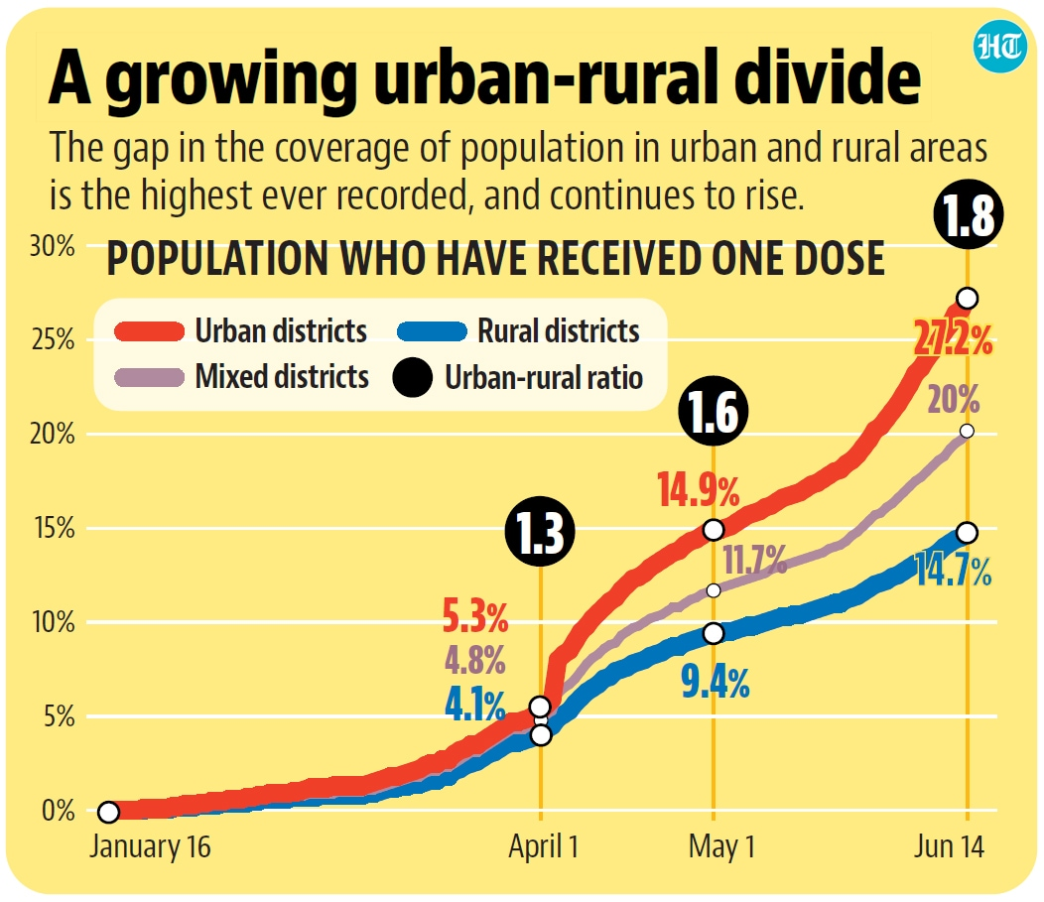

**Figure 1**

Our motivation is to simplify the vaccination process for parents and caregivers while empowering healthcare providers to efficiently manage vaccination records. By digitizing the process, we seek to improve accessibility and accuracy, ultimately leading to better health outcomes for children across India.

Through our platform, we aim to contribute to the overall improvement of child health outcomes by creating a more efficient system for managing vaccinations.

**1.3 Problem statement and Objectives:**

"Develop a user-friendly website named Immunoshield aimed at providing accurate and accessible information about child vaccination. The project's objective is to address the challenge of misinformation and vaccine hesitancy among parents and caregivers. The problem at hand is to design a platform that offers a comprehensive resource for vaccination schedules, vaccine safety, and common concerns. This project should focus on creating an informative and engaging user experience, ensuring that parents can make informed decisions about vaccinating their children. The challenge lies in consolidating trustworthy information from reputable sources like UNICEF, CDC, and WHO and presenting it in an easily understandable format. By doing so, the Immunoshield website will contribute to improving childhood vaccination rates and public health.”

Immunoshield focuses on implementing :

1. Facilitate Seamless Booking: Provide a user-friendly platform for parents and caregivers to easily schedule vaccination appointments for their children, promoting accessibility and convenience.

2. Centralize Record-Keeping: Enable healthcare providers to maintain accurate and up-to-date vaccination records for each child, streamlining record-keeping and enhancing continuity of care.

3. Promote Vaccine Education: Offer reliable information about vaccines, their importance, and safety to parents and caregivers, empowering them to make informed decisions and build confidence in the vaccination process.

**2. Literature Survey:**

| **Research paper** | **Description** |
| --- | --- |
| Vaccination in India: A Review of Current Trends and Future Prospects | Overview of vaccination programs in India, covering coverage rates, challenges, and prospects. |
| Improving Childhood Vaccination Coverage in India: Insights from Recent Studies | Synthesis of recent studies on vaccination coverage, factors influencing uptake, and strategies for improvement. |
| Assessment of Vaccine Hesitancy and Acceptance in Urban and Rural Communities in India | Investigation of vaccine hesitancy and acceptance, exploring factors and strategies to address concerns. |
| Impact of Public Health Campaigns on Childhood Vaccination Coverage in India | A longitudinal study evaluating the impact of public health campaigns on vaccination coverage in India. |
| Barriers to Immunization Coverage in Underserved Communities in India | Qualitative research on barriers to immunization coverage in underserved communities, proposing interventions. |

**2.1 Survey of Existing System:**

- India's child vaccination management system is spearheaded by the national Health Mission (NHM), focusing on immunizing children nationwide, with special attention to critical vaccines like the Measles Rubella (MR) vaccine.

- The primary goal is to eradicate measles and control rubella, aligning with India's commitment to reducing vaccine-preventable diseases.

- The system employs routine child immunization and health management information to monitor vaccination trends and coverage.

- Challenges persist, including the impact of the COVID-19 pandemic on vaccination rates, but India has launched initiatives to strengthen its vaccination system.

- Mission Indradhanush (MI) aims to achieve 90% full immunization coverage for children, especially targeting unreached populations.

- UNICEF collaborates with the government to ensure universal access to vaccination, striving to leave no child without immunization.

- The MR vaccine plays a crucial role in India's strategy for measles and rubella elimination.

- The quality of public health facilities significantly contributes to increased immunization coverage, particularly among children aged 12-23 months.

- These collective efforts reflect India's dedication to providing comprehensive vaccination coverage and improving the overall health of the population.

**2.2 Limitation in the existing system :**

* Limited awareness and accessibility to vaccination schedules among certain communities contribute to suboptimal vaccination rates, necessitating targeted educational campaigns and outreach efforts.

* The COVID-19 pandemic exacerbates existing challenges, including disruptions in healthcare services and vaccine hesitancy, impacting vaccination rates and coverage.

* Outdated or insufficient data management systems hinder accurate tracking of vaccination trends and coverage rates, impeding effective decision-making and resource allocation.

* Addressing vaccine misinformation and hesitancy remains a challenge, requiring tailored strategies to build trust and confidence in vaccination.
* Limited integration and interoperability between healthcare systems hinder the seamless exchange of information, impacting coordination among stakeholders involved in vaccination management.
* No proper system for parents to easily book a vaccine and have their records digitally available to them and their respective doctors

**2.3 Mini Project Contribution:**

1. User Registration and Authentication: Users, including parents and healthcare providers, will be able to register for an account on the platform and securely log in using authentication mechanisms.

2. Vaccination Booking System: Parents can browse available vaccination slots, book appointments for their children, and receive confirmation notifications.

3. Vaccination Tracking Dashboard: Parents will have access to a personalized dashboard where they can view their child's vaccination history, and upcoming doses, and receive reminders for upcoming appointments.

4. Doctor Portal: Healthcare providers will have access to a dedicated portal where they can manage their patients' vaccination schedules, update vaccine administration records, and communicate with parents regarding vaccination status.

5. Dose Updation: The system will automatically update vaccination records based on the doses administered by healthcare providers, ensuring accurate and up-to-date vaccination tracking.

### 

### 

### **3. Proposed System**

### 

3.1 Introduction :

Our proposed vaccination booking and management system represents a groundbreaking initiative aimed at revolutionizing the way childhood vaccinations are managed in India. Harnessing the power of modern web technologies such as HTML, CSS, JavaScript for frontend development, and XAMPP (Apache, MySQL, PHP) for backend functionalities, our system is poised to offer a comprehensive and user-friendly platform for parents and caregivers across the nation. At its core, the system will feature a robust vaccine information portal, serving as a one-stop destination for detailed insights into various vaccines recommended for children in India. Each vaccine will be meticulously documented, providing parents with essential information on indications, dosing schedules, potential side effects, and overall importance.

Moreover, our system will incorporate an advanced appointment booking system, empowering parents to effortlessly schedule vaccination appointments for their children with just a few clicks. Through an intuitive interface, parents will be able to browse available vaccination slots, select their preferred date, time, and vaccination center, and receive instant confirmation notifications to streamline the process further. Furthermore, the system will include a dynamic vaccination tracking dashboard, personalized for each parent upon registration. This dashboard will offer real-time visibility into their child's vaccination history, upcoming doses, and vaccination status, complete with visual indicators to track progress and highlight any overdue doses.

A cornerstone of our system is its automatic reminders and notifications feature, which will play a pivotal role in ensuring adherence to vaccination schedules. Through automated alerts via email or SMS, parents will receive timely reminders for upcoming vaccination appointments, minimizing the risk of missed doses and optimizing vaccination coverage. Additionally, the system will alert parents of any missed appointments or overdue doses, prompting them to take prompt action to reschedule or catch up on vaccinations as necessary.

For healthcare providers, our system will offer a dedicated doctor portal, designed to streamline vaccine management and administration processes. This portal will enable healthcare providers to manage their patients' vaccination schedules, update vaccine administration records, and communicate seamlessly with parents regarding vaccination status and recommendations. With features such as vaccine inventory tracking, vaccination coverage monitoring, and customizable reporting capabilities, the doctor portal will empower healthcare providers to deliver efficient and personalized vaccination services to their patients.

**3.2 Architecture/framework**

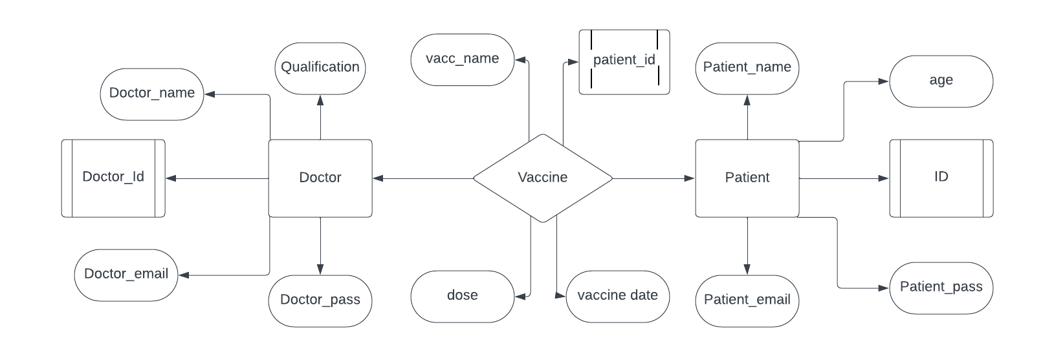

**Figure 2**

**3.3 Algorithm and process Design :**

There are mainly three users of our system

* Doctors
* Parents
* Government

The main starting point is from our landing page which is Immunoshield , in it we have mentioned all the information of what are we, who are we and some details about the vaccinations that are important for the children.

There are two login options one for the doctor and one for the patient , the respective user will login/register by his/her unique id given to him/her by our system

The user will be redirected to either of the doctor page or login page

The doctors can see all the patients under him , so thet he can keep ad update of his individual patients about their vaccination dose and date so as to schedule booking for next vaccine , he can also see the upcoming bookings done by the patients

The parents can login using their unique id and monitor the vaccination report of their child , we have also made it possible to download their vaccination history as a hard proof to carry and the softcopy of this certificate will always be with them ans also gets updated time to time

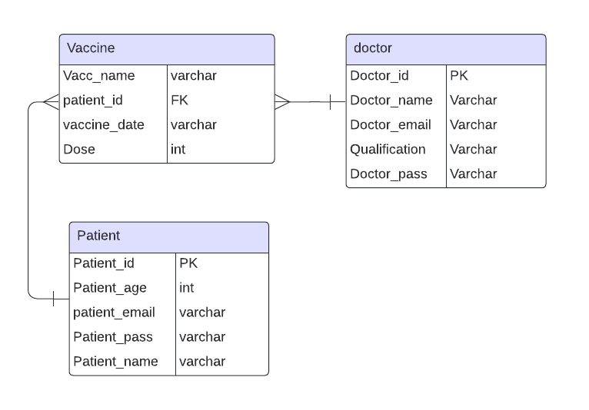

**Figure 3**

**3.4 Details of Hardware & Software:**

3.3.1 Hardware:

* PC: A standard personal computer or laptop.
* WiFi Setup: A WiFi network connection.

3.3.2 Software:

* HTML, CSS, JavaScript: Frontend development.
* XAMPP ( MySQL, PHP): Backend infrastructure.

**3.5 Conclusion & Future scope:**

**3.5.1 Conclusion:**

In conclusion, the development of our vaccination booking and management website, leveraging HTML, CSS, JavaScript for frontend, and XAMPP (Apache, MySQL, PHP) for backend functionalities, holds significant promise in addressing the challenges associated with tracking and managing childhood vaccinations. By providing a user-friendly platform for parents to book appointments, track vaccination schedules, and receive reminders, alongside a dedicated portal for healthcare providers to manage vaccine administration records, our system aims to enhance vaccination adherence and coverage among children in India.

**3.5.2 Future Scope:**

* Mobile Application: Developing a mobile application version of the platform would increase accessibility and convenience for users, allowing them to manage vaccination schedules on-the-go.
* Integration with Electronic Health Records (EHR): Integrating the platform with existing electronic health record systems would streamline data exchange between healthcare providers and ensure comprehensive patient health information management.
* Expansion of Services: Expanding the platform to offer additional healthcare services beyond vaccination management, such as health education resources, telemedicine consultations, and appointment scheduling for other medical services.
* Enhanced Data Analytics: Implementing advanced data analytics capabilities to analyze vaccination trends, identify areas with low vaccination coverage, and tailor targeted interventions to improve overall vaccination rates.

**References**

1. https://www.cdc.gov/index.htm
2. https://www.sciencedirect.com/science/article/pii/S0264410X22012853#ab010
3. Assessment of Child Immunization Coverage and Associated Factors with Full Vaccination among Children.
4. https://www.hindawi.com/journals/ijpedi/2017/7976587/
5. https://bmjopen.bmj.com/content/6/8/e013015
6. https://www.aap.org/en/patient-care/immunizations/